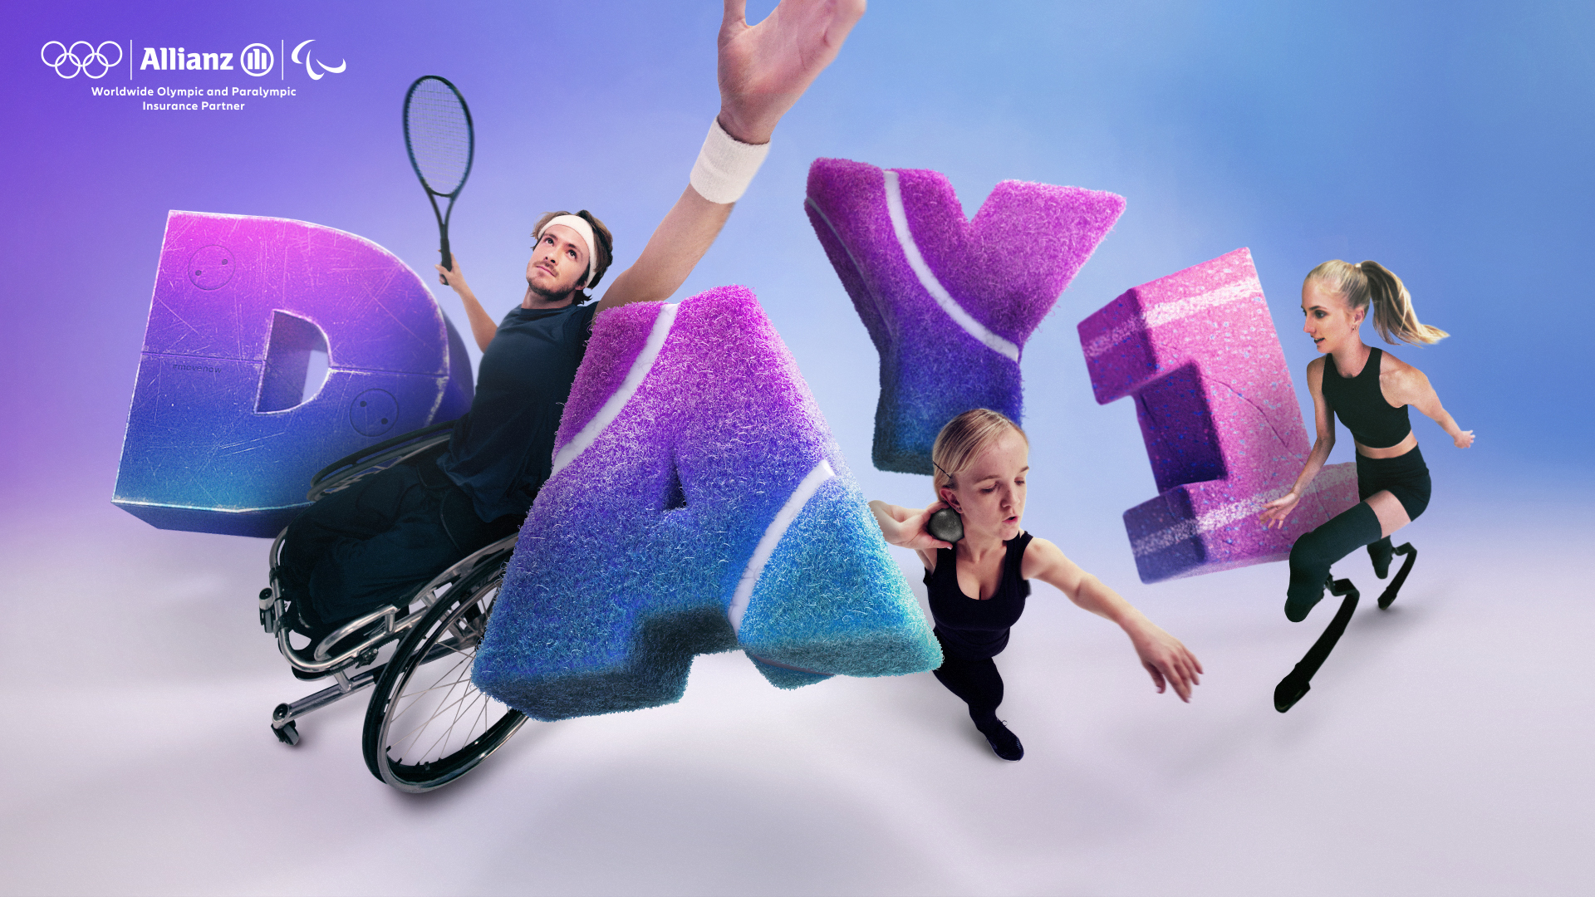

#MoveNow
Training Plan
Created by professional coach Guido Bonsen in collaboration with Paralympic athletes; Nico Langmann, Mary Fitzgerald and Fleur Jong.

Disclaimer:
The following drills can be adapted to suit your individual disability, however they are not fully inclusive.

Let’s do this!

Through our MoveNow programme, we’re committed to getting you moving from Day 1 and beyond. This training plan contains 15 different drills categorised into core areas; strength, explosive power, agility, coordination, balance and flexibility.

On pages 19-21 you’ll find a comprehensive 21-day training plan template, consisting of a combination of drills. Pick your appropriate drills to make it your own.

Each drill is split into a simple 2-step structure that is designed to be repeated. And each one can be adapted to suit your individual disability. However, if some of them aren’t appropriate, simply find another one to complete. Okay, ready? Let’s go!

Content:
- Strength drills
- Explosive power drills
- Agility drills
- Coordination & balance drills
- Flexibility drills
- Daily Plan
- Additional material

Arm Lifts
Good for strengthening shoulders & wrists.

Step 1
Stretch your arms out. Make sure your palms are flat.

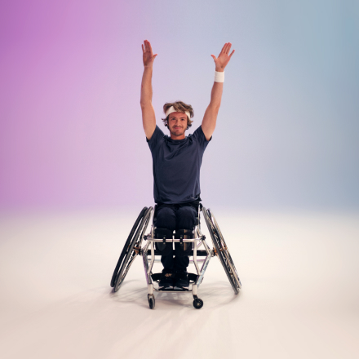

Step 2
Move your wrists up and down with your arms.
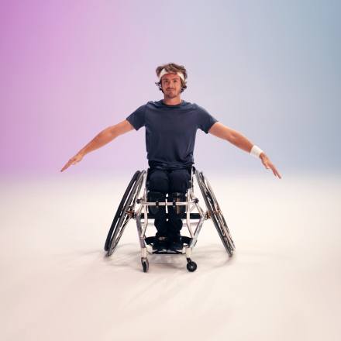

Note:
You can do this standing up or sitting down.

View in action https://Allianz.com/arm-lifts

Power Lifts
Good for strengthening arms.

What you’ll need:

- 2 weighted objects

If you don’t have them, don’t worry. Just grab similar household items.

Step 1
Hold a weighted object like a can of beans in each hand.
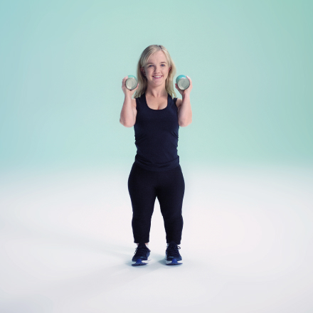

Step 2
Lift them above your shoulders, then back down. Then hold them straight in front of you and lower them.
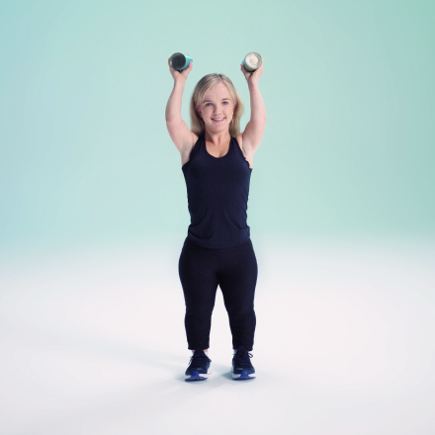

Note:
You can do this standing up or sitting down.

View in action at https://Allianz.com/power-lifts

Hip Lifts
Good for building core strength.

What you’ll need:

- 1 yoga mat

If you don’t have one, don’t worry. Just grab a similar household item.

Step 1
Lie on your back with your legs raised, arms flat on the floor.

Step 2
Lift both legs and hips upwards, towards the sky.

Note:
Alternatively, attempt with both arms stretched upwards.

View in action at https://Allianz.com/hip-lifts

Rocket
Good for improving explosive power in your arms and legs.

What you’ll need:

- 1 water bottle

If you don’t have one, don’t worry. Just grab a similar household item.

Step 1
Crouch down as low as possible, holding a water bottle. Alternatively, if you’re seated hold the water bottle at full arm’s length, as low as you can.

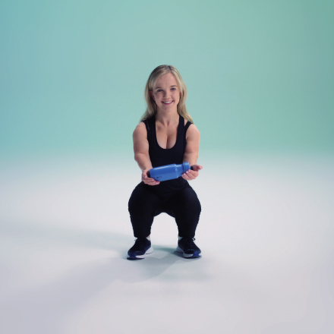

Step 2
Push yourself upwards to launch the water bottle like a rocket, then catch it. Alternatively, if you’re seated lift your arms as fast as possible to launch the water bottle like a rocket, then catch it.
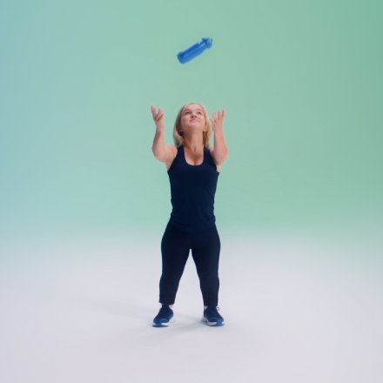

View in action at https://Allianz.com/rocket

Power Hops
Good for developing explosive power in your legs

Step 1
Stand with feet shoulders width apart and bend your knees.
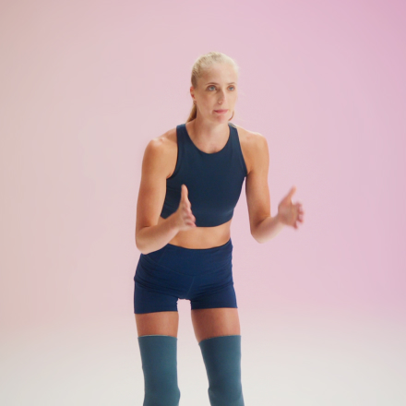

Step 2
Jump forwards 5 metres.

Note:
Alternatively, attempt to hop on one leg. Then alternate.

View in action at https://Allianz.com/power-hops

Speed Slalom
Good for improving agility.

What you’ll need:

- 5 training cones

If you don’t have them, don’t worry. Just grab similar household items.

Step 1
Place 5 objects on the ground, 1 metre apart. You can use cones, t-shirts, water bottles etc.
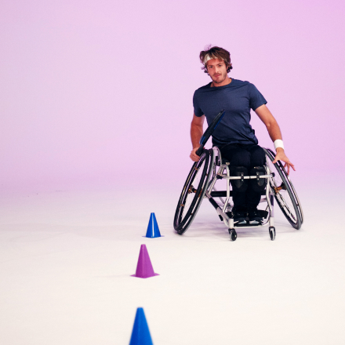

Step 2
Move around the objects as smoothly as possible and slowly increase your speed.

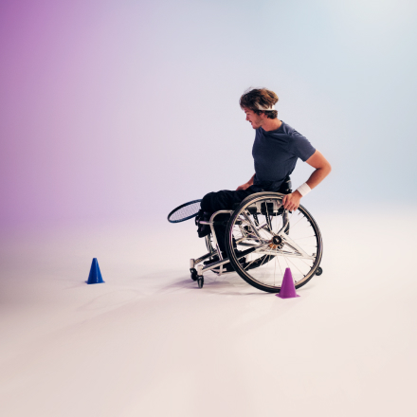

View in action at https://Allianz.com/super-slalom

Shuttle Dash
Good for improving explosive acceleration.

What you’ll need:

- 5 tennis balls
- 1 bucket

If you don’t have them, don’t worry. Just grab similar household items.

Step 1
Place 5 tennis balls and a small bucket on the floor, around 5 metres apart. If you don’t have tennis balls you can use golf balls, apples or stones.

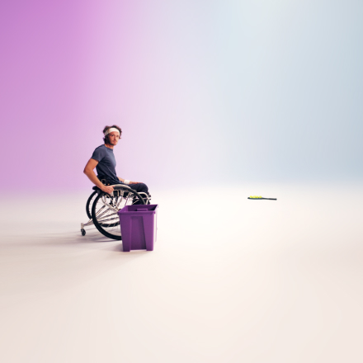

Step 2
Start by the bucket and move as quickly as you can and pick up a tennis ball, turn and drop it in the bucket. Complete this until all 5 items are in the bucket.

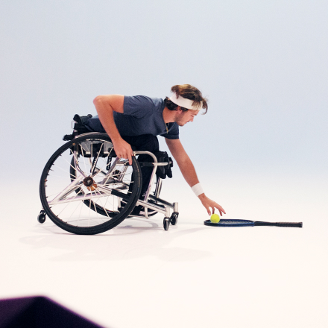

View in action at https://Allianz.com/shuttle-dash

Dishcloth Challenge
Good for improving speed.

What you’ll need:

- 1 dishcloth

If you don’t have one, don’t worry. Just grab a similar household item.

Step 1
Hold the dishcloth in one hand, either standing up or sitting down.

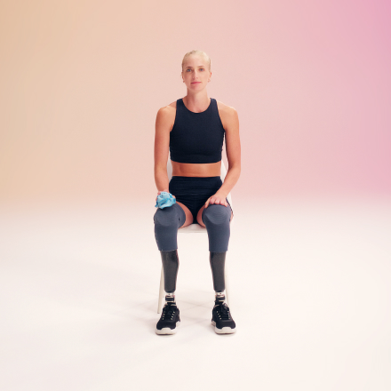

Step 2
Throw the dishcloth in the air and move your legs (or arms) as fast as possible before you catch the dishcloth again.
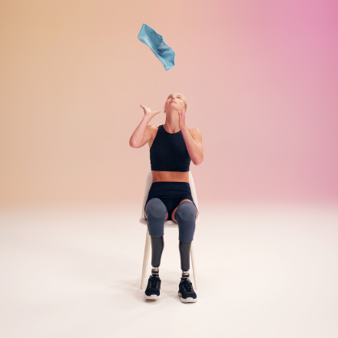

Note:
Alternatively, you can do this drill without a dishcloth by counting to 2 seconds as you move your legs or arms as fast as possible.

View in action at https://Allianz.com/dishcloth-challenge

Double Juggle
Good for coordination.

What you’ll need:

- 2 tennis balls

If you don’t have them, don’t worry. Just grab similar household items.

Step 1
Hold a tennis ball in each hand.
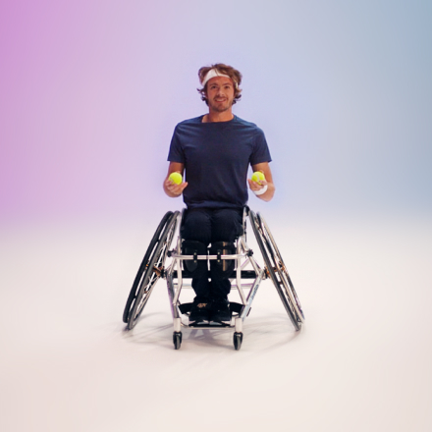

Step 2
Throw them up at the same time and catch them at the same time.

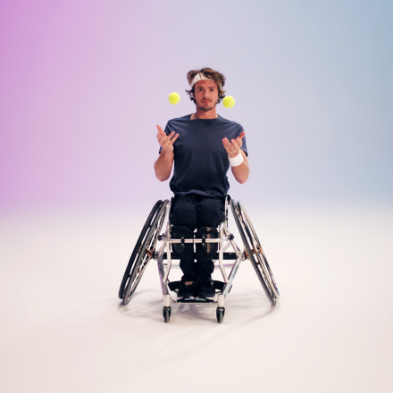

Note:

Alternatively, you can throw one ball up and catch with both hands. Or simply pass the ball from one hand to the other. This is still good for coordination and muscle development.

View in action at https://Allianz.com/double-juggle

Balance Ball
Good for improving hand-eye coordination.

What you’ll need:

- 1 tennis racket
- 1 tennis ball

If you don’t have them, don’t worry. Just grab similar household items.

Step 1
Hold a tennis racket (or frying pan) in front of you.

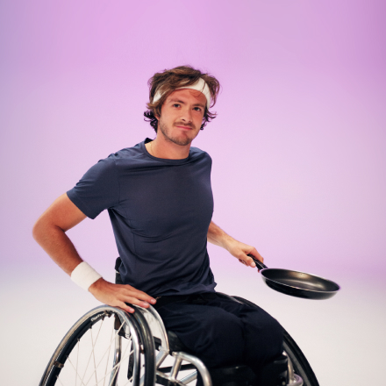

Step 2
Slowly move the ball around the rim. To make it more challenging, speed it up.
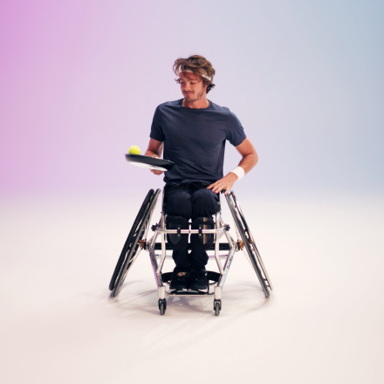

Note:
You can attempt this standing up or sitting down. And try moving the ball around the rim in both directions.

View in action at https://Allianz.com/balance-ball

Clock Twists
Good for coordination and balance.

What you’ll need:

- 4 training cones

If you don’t have them, don’t worry. Just grab similar household items.

Step 1
Stand with feet shoulders width apart - and face forwards at 12 o’clock. If you’re seated, sit upright with shoulders open and chest out.
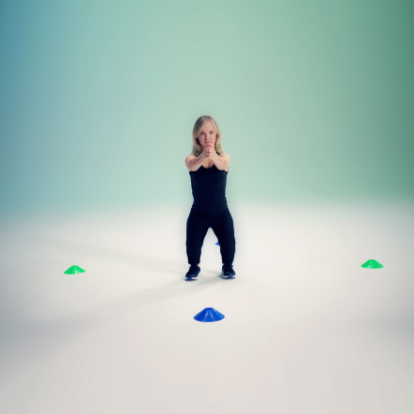

Step 2
Get someone to shout out numbers between 1 and 12 and twist your body to that direction on the imaginary clock face, keeping your arms high.

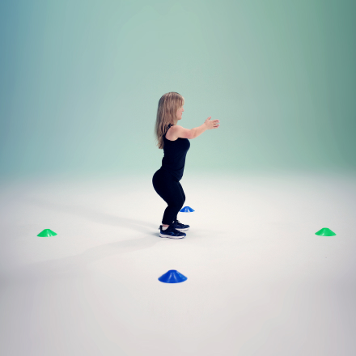

Note:
You can shout out the numbers yourself.

View in action at https://Allianz.com/clock-twists

Ready Steady
Good for improving balance.

What you’ll need:

- 1 weighted object

Step 1
Hold a can of beans by the side of your neck. Then stretch your other arm outwards horizontally, whilst standing on one leg. If you’re seated stretch one arm outwards, leaning as far as you can.

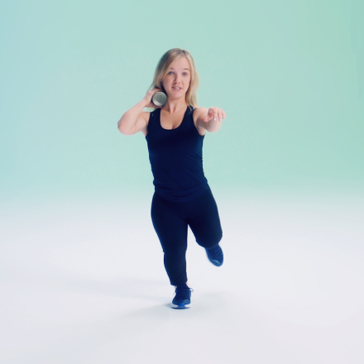

Step 2
Lift the can of beans up and then down.

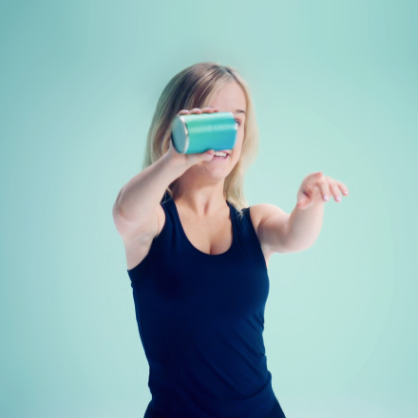

Note:
Alternatively, try this drill standing on both legs.

View in action at https://Allianz.com/ready-steady

By the Book
Good for posture and balance.

What you’ll need:

- 1 book

If you don’t have one, don’t worry. Just grab a similar household item.

Step 1
Stand up and place a book on your head.
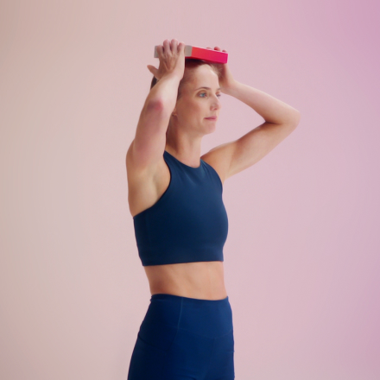

Step 2
Try to move forward with high knees, whilst balancing the book on your head.

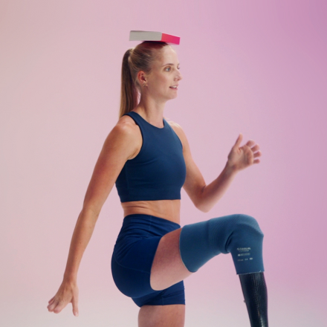

Note:
Alternatively, try this drill without balancing a book on your head.

View in action at https://Allianz.com/by-the-book

Flexi-Throw
Good for flexibility.

What you’ll need:

- 1 tennis ball

If you don’t have one, don’t worry. Just grab a similar household item.

Step 1
Shoulders open, chest up. Hold 4 fingers behind the ball, with your elbows up.

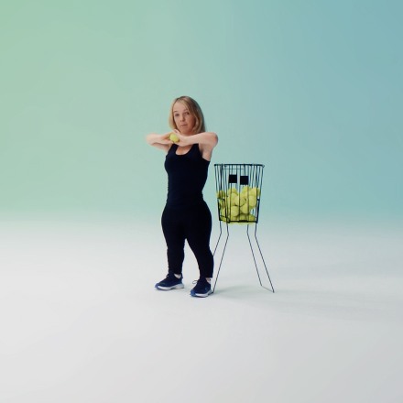

Step 2
Launch the ball - like a basketball throw - at a target on the floor (you can use a hoop or a net as your target).

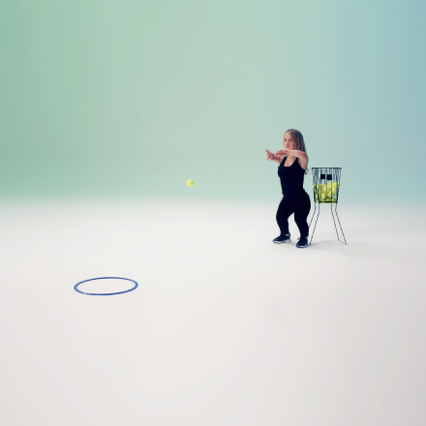

View in action at https://Allianz.com/flexi-throw

Flexi-Knees
Good for improving flexibility and balance.

Step 1
Lift both elbows up above your head.

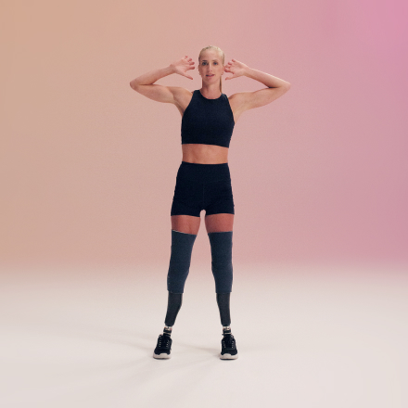

Step 2
Balance on one leg and lift your knee upwards to touch your alternate elbow. Then alternate.

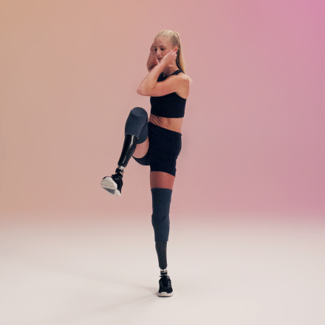

Note:
Alternatively, lift one leg up and try to touch your knee with your alternate hand.

View in action at https://Allianz.com/flexi-knees

Coach notes
The most important thing for improvement is variation. The human body is very lazy and if you do something twice the second time is less effective because the body anticipates it. That’s why I have specifically designed this Training Plan to be as varied as possible;

- Different drills/exercises
- Varying repetition and time
- Increasing the number of sets
- Reducing rest times

This will also give you the opportunity to repeat drills you’re comfortable with as well as introducing new drills into your training plan. Best of luck.

Guido Bonsen - Professional Paralympic coach

Rep: It’s short for “repetition”. Reps keep track of your workout. Each time you complete the entire movement that’s called a rep.

Set: Completing several reps of a specific exercise in a row is called a set.

Rest: This is the amount of ‘rest’ time you get in-between a set, so you can take a breather and have some water.

Daily Plan/ Record

Day | Drill | Example | Set | Reps or Time | Rest | Completed
1 | Strength | Arm Lifts | 1 | 30 | – | Yes/No
 | Agility | Dishcloth Challenge | 1 | 10 | – | Yes/No
 | Flexibility | Flexi-Throw | 1 | 30 | – | Yes/No
2 | Explosive power | Rocket | 1 | 10 | – | Yes/No
 | Coordination & balance | Balance Ball | 1 | 10 | – | Yes/No
 | Agility | Dishcloth Challenge | 2 | 10 | 2 min | Yes/No
3 | Flexibility | Flexi-Knees | 1 | 30 | 2 min | Yes/No
 | Explosive power | Power Hops | 3 | 10 | 1 min | Yes/No
 | Strength | Arm lifts | 3 | 30 | 1 min | Yes/No
4 | Agility | Shuttle Dash | 1 | 10 | – | Yes/No
 | Flexibility | Flexi-Knees | 2 | 20 | 1 min | Yes/No
 | Coordination & balance | Balance Ball | 2 | 10 | – | Yes/No
5 | Strength | Arm Lifts | 3 | 20 | 1 min | Yes/No
 | Agility | Dishcloth Challenge | 3 | 10 | 2 min | Yes/No
 | Flexibility | Flexi-Throw | 2 | 20 | – | Yes/No
6 | Explosive power | Rocket | 2 | 10 | – | Yes/No
 | Coordination & balance | Double Juggle | 1 | 10 | – | Yes/No
 | Agility | Dishcloth Challenge | 4 | 10 | 2 min | Yes/No
7 | Flexibility | Flexi-Throw | 3 | 15 | – | Yes/No
 | Explosive power | Power Hops | 2 | 20 | 1 min | Yes/No
 | Strength | Arm Lifts | 4 | 10 | 1 min | Yes/No
8 | Strength | Arm Lifts | 5 | 10 | – | Yes/No
 | Agility | Dishcloth Challenge | 3 | 20 | – | Yes/No
 | Flexibility | Flexi-Throw | 3 | 30 | – | Yes/No
9 | Explosive power | Rocket | 3 | 20 | – | Yes/No
 | Coordination & balance | Balance Ball | 2 | 20 | – | Yes/No
 | Agility | Dishcloth Challenge | 5 | 10 | 2 min | Yes/No
10 | Flexibility | Flexi-Knees | 3 | 20 | 2 min | Yes/No
 | Explosive power | Power Hops | 4 | 10 | 1 min | Yes/No
 | Strength | Arm lifts | 2 | 20 | 1 min | Yes/No
11 | Agility | Shuttle Dash | 2 | 20 | – | Yes/No
 | Flexibility | Flexi-Knees | 2 | 30 | 1 min | Yes/No
 | Coordination & balance | Balance Ball | 3 | 10 | – | Yes/No
12 | Strength | Arm Lifts | 3 | 30 | 1 min | Yes/No
 | Agility | Dishcloth Challenge | 4 | 10 | 1 min | Yes/No
 | Flexibility | Flexi-Throw | 4 | 20 | – | Yes/No
13 | Explosive power | Rocket | 3 | 10 | – | Yes/No
 | Coordination & balance | Double Juggle | 2 | 20 | – | Yes/No
 | Agility | Dishcloth Challenge | 5 | 20 | 2 min | Yes/No
14 | Flexibility | Flexi-Throw | 4 | 20 | – | Yes/No
 | Explosive power | Power Hops | 3 | 20 | 1 min | Yes/No
 | Strength | Arm Lifts | 4 | 20 | 1 min | Yes/No
15 | Strength | Arm Lifts | 5 | 30 | – | Yes/No
 | Agility | Dishcloth Challenge | 4 | 20 | – | Yes/No
 | Flexibility | Flexi-Throw | 4 | 20 | – | Yes/No
16 | Explosive power | Rocket | 4 | 20 | – | Yes/No
 | Coordination & balance | Balance Ball | 3 | 20 | – | Yes/No
 | Agility | Dishcloth Challenge | 4 | 20 | 1 min | Yes/No
 | Strength | Hip Lifts | 2 | 20 | 1 min | Yes/No
17 | Flexibility | Flexi-Knees | 3 | 20 | – | Yes/No
 | Explosive power | Power Hops | 4 | 30 | – | Yes/No
 | Strength | Arm lifts | 2 | 10 | 1 min | Yes/No
 | Agility | Shuttle Dash | 2 | 20 | – | Yes/No
18 | Agility | Shuttle Dash | 2 | 20 | – | Yes/No
 | Flexibility | Flexi-Knees | 2 | 10 | 2 min | Yes/No
 | Coordination & balance | Balance Ball | 3 | 20 | 1 min | Yes/No
 | Strength | Power Lifts | 2 | 20 | 1 min | Yes/No
19 | Strength | Arm Lifts | 3 | 30 | – | Yes/No
 | Agility | Dishcloth Challenge | 4 | 10 | 1 min | Yes/No
 | Flexibility | Flexi-Throw | 4 | 20 | 1 min | Yes/No
 | Explosive power | Rocket | 3 | 20 | – | Yes/No
20 | Explosive power | Rocket | 3 | 10 |  | Yes/No
 | Coordination & balance | Double Juggle | 2 | 20 |  | Yes/No
 | Agility | Dishcloth Challenge | 5 | 20 |  | Yes/No
 | Strength | Power Lifts | 3 | 20 |  | Yes/No
 | Flexibility | Flexi-knees | 4 | 20 |  | Yes/No
21 | Flexibility | Flexi-Throw | 4 | 20 | – | Yes/No
 | Explosive power | Power Hops | 3 | 20 | – | Yes/No
 | Strength | Arm Lifts | 4 | 20 | 1 min | Yes/No
 | Coordination & balance | Balance Ball | 4 | 20 | 1 min | Yes/No
 | Agility | DIshcloth Challenge | 5 | 20 | 1 min | Yes/No

Day | Notes
1
2
3
4
5
6
7
8
9
10
11
12
13
14
15
16
17
18
19
20
21

Want more?
Through our MoveNow programme, we’re committed to supporting more people move around the world, through 24 initiatives in the upcoming months until the Olympic and Paralympic Games in Paris 2024. So follow Allianz on social platforms such as Instagram, Twitter and YouTube and stay tuned!

However, if you haven’t found any of our drills that work for you, we’d love to hear from you to take on feedback and input in designing the next wave as inclusively as we can.

Contact: olympics@allianz.com

Website:
www.allianz.com/MoveNow

Instagram:
@allianz

Twitter:
@allianz

